

Department of Electrical Engineering

Group  Number | 07

A PROJECT REPORT ON

Project SwiftVoltKit: Streamlined Assembly and Testing of Janitza Class A Analyser

Submitted by

Project Team
PRN Number | Name of Student
22110032 | Mr.Omkar N. Koli
22110038 | Ms.Sai G. Patade
22110048 | Mr.Aditya S. Salunke
22110054 | Mr.Yash C. Sonje
22110059 | Mr.Mayur M. Vaidya

In partial fulfilment of S.Y. B.Tech (Electrical Engineering)
EndSem of course
“Electrical Measurements” [ELPCC303 – Sem - III]

Academic Year : 2023-24
CERTIFICATE

This is to certify that the project report entitled “Project SwiftVoltKit: Streamlined Assembly and Testing of Janitza Class A Analyser”
Submitted by
PRN Number | Name of Student
22110032 | Mr.Omkar N. Koli
22110038 | Ms.Sai G. Patade
22110048 | Mr.Aditya S. Salunke
22110054 | Mr.Yash C. Sonje
22110059 | Mr.Mayur M. Vaidya

is a bonafide work carried out by above students under the supervision of Mr. Sachin Shelar & Ms. Poonam Mane and it is approved for the partial fulfilment of the end semester examination of course “Electrical Measurements” [ELPCC303 – Sem - III] of Second Year B. Tech Electrical Engineering program.

Mr. Sachin V. Shelar  Internal Guide  Department of Electrical Engineering | Dr. Ashpana D. Shiralkar  Head of Department  Department of Electrical Engineering
External Examiner

Date:
Place: Pune

Abstract

The Swiftvolt Kit represents a groundbreaking initiative in response to the escalating demand for precise power quality measurement tools in industrial and residential sectors. By harnessing the capabilities of the Janitza UMG 512 Pro Class A Analyser, the project extends its functionality with advanced features, including transient analysis, offering an unparalleled depth of diagnostic capabilities. This enhancement enables the Swiftvolt Kit to effectively identify and analyze transient events, providing critical insights into the stability and reliability of the power supply.
Moreover, the project focuses on user-friendly adaptability, featuring a comprehensive interface for the Janitza analyser. This interface streamlines configuration, facilitates real-time data visualization, and ensures efficient data retrieval, catering to users with varying technical expertise. The Swiftvolt Kit, therefore, stands not only as a powerful technical solution but also as an accessible and practical tool for a diverse user base, accommodating both experienced professionals and those new to power quality analysis.
In conclusion, the Swiftvolt Kit is positioned as a comprehensive solution for power quality analysis, addressing the broader needs of diverse user bases and the evolving demands of modern power systems. With its integration of advanced features and a user-friendly interface, this kit is poised to make a significant impact in the fields of industrial and residential power quality monitoring, contributing to the assurance of stable and reliable power.

qqq

Table of Contents
Chapter : 1 Introduction 1
Chapter : 2 Problem statement & Objectives 2
2.1. Problem statement 2
2.1. Objectives 3
Chapter : 3 Hardware Design 5
3.1. Introduction to Hardware Part 5
3.1.1 Block diagram 7
3.1.2 Explanation of block diagram 7
3.2. Selection of components 8
3.2.1 Component 1: Janitza UMG 512 Pro Class A Analyser: 10
3.2.2 Component 2: Janitza Rogowski Current Transformer Rogotrans 11
3.2.3 Component 3: Switched Mode Power Supply (SMPS): 12
3.2.4 Component 4: Rogowski Coils 13
3.3. Hardware 14
Chapter : 4 Costing 16
Chapter : 5 Member work sheet 17
Chapter : 6 Datasheets 18

Introduction
The Swiftvolt Kit emerges as a pioneering venture in the realm of power quality measurement, responding to the escalating demands for precision and versatility in both industrial and residential electrical systems. In the contemporary landscape, where the stability and reliability of power sources are of paramount importance, this project introduces a comprehensive solution anchored by the Janitza UMG 512 Pro Class A Analyser. This cutting-edge instrument not only furnishes the kit with robust measurement capabilities but also opens avenues for advanced features, prominently the integration of transient analysis. The inclusion of transient analysis represents a significant stride, endowing the Swiftvolt Kit with the ability to delve deeper into the intricacies of power supply dynamics, providing critical insights into transient events that might impact the overall stability of electrical systems.
The foundation of the Swiftvolt Kit is grounded in a meticulous selection of components, with a focus on ensuring accurate measurements and reliable performance. By seamlessly incorporating Rogotrans, an SMPS, and Rogowski coils, the project aims to streamline the assembly and testing processes, promising swift deployment of the Janitza analyser for real-time power quality assessments. This amalgamation of advanced instrumentation and optimized assembly processes positions the Swiftvolt Kit as an indispensable tool for professionals tasked with monitoring and optimizing power quality in diverse settings.
As our societies become increasingly reliant on stable and efficient power sources, the Swiftvolt Kit steps into the spotlight as a tangible solution, not merely as an assemblage of components, but as an innovative approach to empower industries and households with the insights needed to ensure a consistent and reliable power supply. In this introduction, the Swiftvolt Kit unveils itself as a project poised to redefine the landscape of power quality analysis, promising advancements that are not only timely but imperative in the face of evolving electrical demands.

Problem statement & Objectives

Problem statement
The contemporary landscape of industrial and residential power systems is confronted with a pressing challenge,the imperative need for precise, portable, and versatile solutions for power quality measurement. Current technologies often fall short in providing a comprehensive tool that seamlessly integrates with existing systems while offering advanced features crucial for understanding the complexities of power dynamics. In this context, the Swiftvolt Kit emerges in response to this persistent problem, aiming to bridge the existing gap in power quality analysis tools.
Power quality issues, ranging from voltage fluctuations to transient events, have profound implications on the efficiency and reliability of electrical systems. Existing solutions often lack the agility to adapt to diverse settings, hindering professionals from swiftly and accurately assessing power quality in real-time. Furthermore, the absence of a streamlined assembly and testing process exacerbates the challenge, impeding the rapid deployment of sophisticated analyzers like the Janitza UMG 512 Pro Class A Analyser.
The Swiftvolt Kit seeks to address this problem by offering a comprehensive solution that not only integrates state-of-the-art instrumentation but also optimizes the assembly and testing procedures. The absence of a standardized, streamlined approach to power quality analysis has hindered professionals in swiftly and accurately assessing the stability and reliability of electrical systems. The Swiftvolt Kit, therefore, positions itself as the remedy to these challenges, promising a comprehensive and efficient solution to power quality measurement.
In essence, the problem at hand is the inadequacy of current power quality measurement tools to meet the growing demands of modern electrical systems. The Swiftvolt Kit, through its integrated approach and advanced features, aims to revolutionize power quality analysis by offering a versatile, reliable, and expedited solution, addressing the critical challenges faced by industries and households in ensuring a stable and consistent power supply.

Objectives
The objectives of the Swiftvolt Kit project are multifaceted, addressing key aspects to ensure its effectiveness and impact in the realm of power quality measurement. The primary goals are as follows:
1.Streamlined Assembly Process:
Objective: To develop an assembly process that is efficient and user-friendly, allowing for the swift integration of components, especially the Janitza UMG 512 Pro Class A Analyser, into the Swiftvolt Kit.
Rationale: A streamlined assembly process ensures that the kit can be quickly and easily put together, reducing deployment time and making it accessible to a broader range of users.
2.Optimized Testing Procedures:
Objective: To establish testing procedures that rigorously assess the functionality and reliability of the Swiftvolt Kit under various conditions, ensuring accurate power quality measurements.
Rationale: Comprehensive testing guarantees the performance of the kit in diverse settings, providing users with confidence in its ability to deliver precise and dependable results.
3.Integration of Advanced Features:
Objective: To leverage the capabilities of the Janitza UMG 512 Pro, including advanced features like transient analysis, to enhance the diagnostic capabilities of the Swiftvolt Kit.
Rationale: Advanced features broaden the scope of the kit, allowing users to delve deeper into power dynamics and gain critical insights into transient events, contributing to a more thorough power quality analysis.
4.User-Friendly Interface Design:
Objective: To design a user interface for the Janitza analyser that is intuitive and accessible, catering to users with varying levels of technical expertise.
Rationale: A user-friendly interface ensures that the Swiftvolt Kit is not only a powerful tool but also practical for a diverse user base, encouraging broader adoption and usability.

5.Cost-Effective Solution:
Objective: To develop the Swiftvolt Kit as a cost-effective solution, justifying the budget while providing high-quality power quality measurement capabilities.
Rationale: Cost-effectiveness enhances the accessibility of the kit, making it feasible for a range of applications and industries without compromising on performance.
In summary, the objectives of the Swiftvolt Kit project encompass efficiency in assembly and testing, the integration of advanced features, user-friendly design, cost-effectiveness, and a consideration for environmental impact, collectively aiming to provide a comprehensive and impactful solution to power quality measurement challenges.

Hardware Design

Introduction to Hardware Part
The Swiftvolt Kit project marks a significant stride in the domain of power quality measurement, particularly from a hardware perspective. At its core, the project endeavors to overcome the prevalent challenges in existing power quality analysis tools by introducing a meticulously designed system that leverages cutting-edge hardware components. This hardware-centric approach is crucial in ensuring the reliability, efficiency, and adaptability of the Swiftvolt Kit in addressing the diverse and dynamic needs of power systems.
The overarching objective of the hardware component integration is to create a seamlessly interconnected system capable of swift and accurate power quality assessments. Through a carefully devised block diagram, the hardware elements such as the Janitza UMG 512 Pro Class A Analyser, Rogotrans, SMPS, and Rogowski coils are strategically positioned and interconnected, forming the backbone of the Swiftvolt Kit's functionality.
Delving into the intricacies of the block diagram, each hardware component plays a distinct role in the overall system. The Janitza UMG 512 Pro, chosen for its advanced capabilities, serves as the analytical powerhouse, capturing and processing critical electrical parameters. Rogotrans and the SMPS collectively ensure a stable and efficient power supply, while Rogowski coils enhance the kit's versatility by measuring current in a non-intrusive manner.
The selection of these hardware components is guided by stringent criteria, including reliability, accuracy, and compatibility with the overarching project goals. This choice is underpinned by the aim to create a user-friendly and efficient power quality measurement system that is accessible to a wide spectrum of users.
As we navigate through the hardware specifications, a comprehensive understanding of each component's technical attributes emerges. These specifications not only validate the suitability of the chosen hardware for the project but also provide users with a clear insight into the capabilities of the Swiftvolt Kit.
The costing aspect ensures that the project remains economically viable without compromising on the quality and functionality of the hardware. Transparent budget allocation for each hardware component is essential in justifying financial considerations and demonstrating a prudent approach to resource utilization.
Lastly, the Swiftvolt Kit's hardware perspective acknowledges the importance of environmental considerations. While the primary focus is on functionality, efforts are made to align hardware choices with eco-friendly practices, minimizing the project's environmental footprint where possible.
In summary, the hardware perspective within the introduction to the project sets the stage for a comprehensive exploration of the Swiftvolt Kit's physical components, their interplay, selection rationale, specifications, costing, and a conscientious approach to environmental impact.

Block diagram
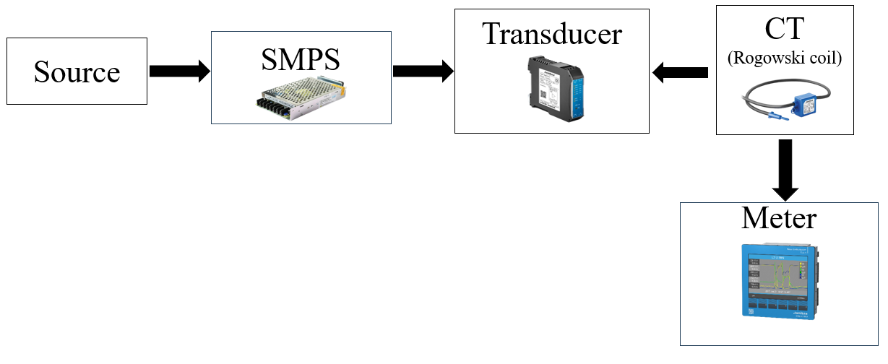

Fig 1: Block Diagram Of Working Components

Explanation of block diagram
Data Flow:
The power source supplies 230V AC, which is then converted to a stable 24V DC by the SMPS.
The Rogotrans ensures compatibility by transforming voltage levels before reaching the Janitza Analyser.
The Rogowski Coils, positioned in parallel, enable non-intrusive current measurement by sensing around conductors.
The Janitza Analyser processes data from all components, performing power quality analysis and providing valuable insights.
Interconnections:
The Janitza Analyser is the central hub, directly connected to Rogotrans, SMPS, and Rogowski Coils.
Rogotrans and SMPS are sequentially connected, ensuring a continuous and stable power supply to the Janitza Analyser.
Rogowski Coils operate in parallel to the power supply components, providing an alternative pathway for current measurement.

Selection of components
The backbone of the Swiftvolt Kit's effectiveness lies in the meticulous selection of its hardware components, a process driven by a keen understanding of the project's goals and the specific requirements of power quality measurement. Each component has been carefully chosen to contribute to the overall reliability, efficiency, and versatility of the kit.
1.Janitza UMG 512 Pro Class A Analyser: The cornerstone of the Swiftvolt Kit, the Janitza UMG 512 Pro is selected for its advanced analytical capabilities, meeting the project's objective of providing precise measurements for a comprehensive range of electrical parameters. Its Class A accuracy ensures reliable data, and its integration allows for sophisticated power quality analysis.
2.Rogotrans and SMPS: Rogotrans and the Switched Mode Power Supply (SMPS) are integral components chosen to ensure a stable and efficient power supply. Rogotrans serves the purpose of transforming voltage levels efficiently, while the SMPS converts AC to DC power, providing a reliable and constant 24V supply to the system. The selection of these components is driven by their compatibility with the Janitza analyser and their role in maintaining a consistent power source.
3.Rogowski Coils: The inclusion of Rogowski coils in the Swiftvolt Kit is deliberate, as they offer a non-intrusive and flexible means of measuring current. These coils provide a crucial layer of versatility to the system, allowing for accurate current measurement without disrupting the electrical circuit. Their selection aligns with the project's goal of creating a solution that is adaptable to various scenarios.
4.Compatibility and Integration: The selection process emphasizes compatibility among components to create a harmonious and integrated system. Compatibility ensures that each component seamlessly communicates with others, contributing to a smooth flow of data and enhancing the overall efficiency of the Swiftvolt Kit.
5.Reliability Criteria: Reliability is a key criterion driving the selection of each component. The goal is to create a system that consistently delivers accurate measurements under diverse conditions. Each chosen component undergoes scrutiny for its track record, durability, and adherence to industry standards, ensuring the reliability of the Swiftvolt Kit.
6.Scalability and Future-Proofing: The components are chosen with an eye toward scalability and adaptability to future advancements. This forward-thinking approach ensures that the Swiftvolt Kit remains relevant and can be updated to accommodate emerging technologies, extending its lifespan and usability.
7.User-Friendly Considerations: The selection of components is guided by a commitment to user-friendliness. The goal is to create a kit that is accessible to a broad range of users, from seasoned professionals to those new to power quality analysis. This consideration influences the design of the Swiftvolt Kit to be intuitive and easy to use.
In conclusion, the selection of components is a strategic and thoughtful process, driven by the project's overarching goals of reliability, efficiency, versatility, and user-friendliness. Each chosen component contributes uniquely to the Swiftvolt Kit's ability to provide a streamlined and accurate solution for power quality measurement.

Component 1: Janitza UMG 512 Pro Class A Analyser:
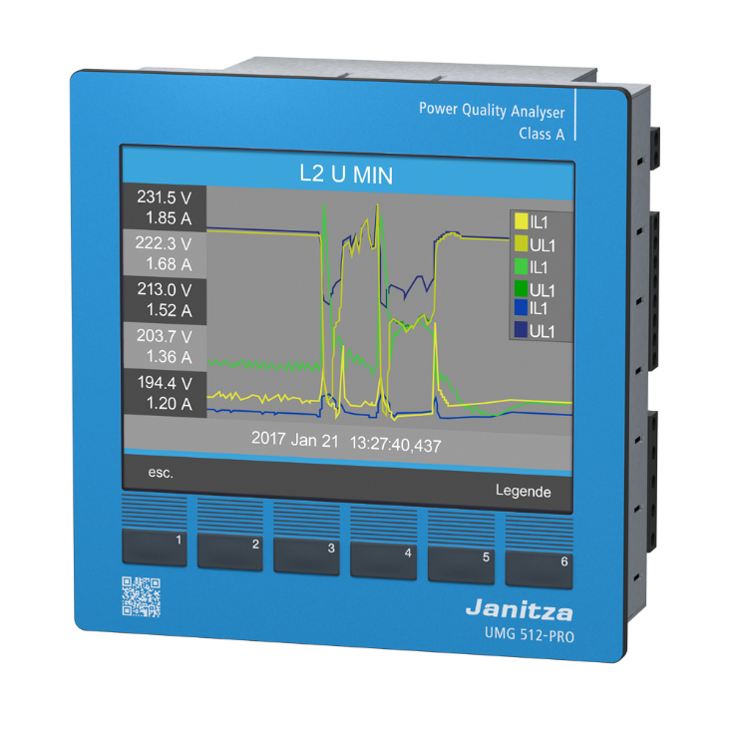

Fig 2: Image Of Janitza UMG 512 Pro Class A Analyser
The Janitza UMG 512 Pro is the heart of the Swiftvolt Kit, embodying advanced power quality measurement capabilities.
Functionality: The UMG 512 Pro is equipped to measure a comprehensive range of electrical parameters, including voltage, current, power factor, frequency, and transient events.
Its Class A accuracy ensures highly reliable and precise measurements, making it suitable for demanding industrial and residential applications.
Key Features: Transient Analysis: The analyser's ability to conduct transient analysis provides valuable insights into sudden voltage variations or disturbances.
Communication Interfaces: Incorporates communication interfaces like Modbus and Ethernet for seamless integration with other components in the kit.
Applications: Widely applicable in industries and residential buildings for real-time monitoring of power quality, enabling timely corrective measures.

Component 2: Janitza Rogowski Current Transformer Rogotrans
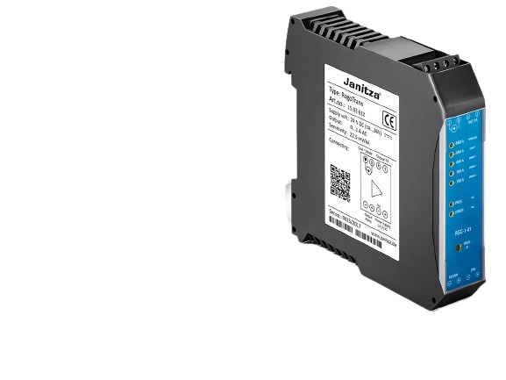

Fig 3: Janitza Rogowski Current Transformer Rogotrans

Rogotrans plays a crucial role in transforming voltage levels efficiently within the Swiftvolt Kit.
Functionality: Acts as a voltage transformer, ensuring the compatibility of different voltage levels within the power supply system.
Provides a stable output suitable for powering sensitive equipment like the Janitza UMG 512 Pro.
Key Features: Efficient Transformation: Rogotrans is designed for efficient and precise voltage transformation, minimizing energy losses during the conversion process.
Applications: Integral in creating a stable and compatible power supply system, contributing to the reliability of the Swiftvolt Kit.

Component 3: Switched Mode Power Supply (SMPS):

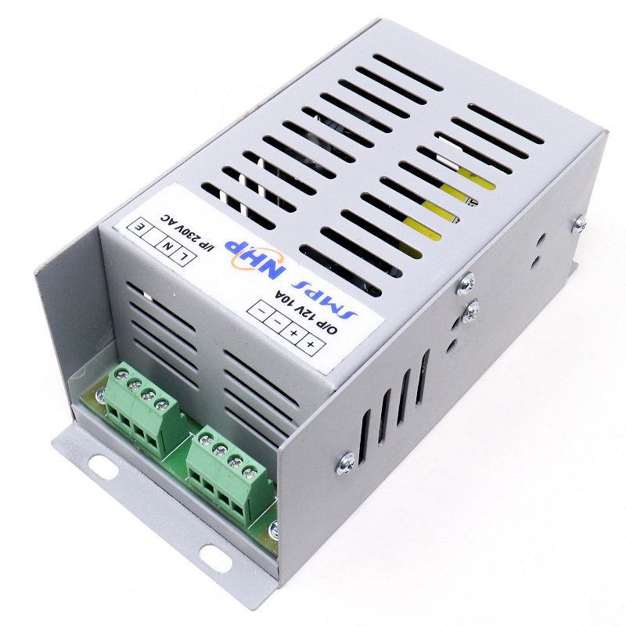

Fig 4: Image of SMPS
SMPS is responsible for converting AC to DC power, providing a consistent and reliable 24V power source.
Functionality: Converts 230V AC to 24V DC, ensuring a stable and uniform power supply for the entire Swiftvolt Kit.
Capable of delivering 5 amperes of current, meeting the power requirements of the integrated components.
Key Features: Compact Design: SMPS is chosen for its compact design, making it suitable for portable applications like the Swiftvolt Kit.
High Efficiency: The switched mode operation ensures high energy efficiency, minimizing heat dissipation.
Applications: Critical for powering the Janitza analyser and other components, ensuring they operate reliably and consistently.

Component 4: Rogowski Coils

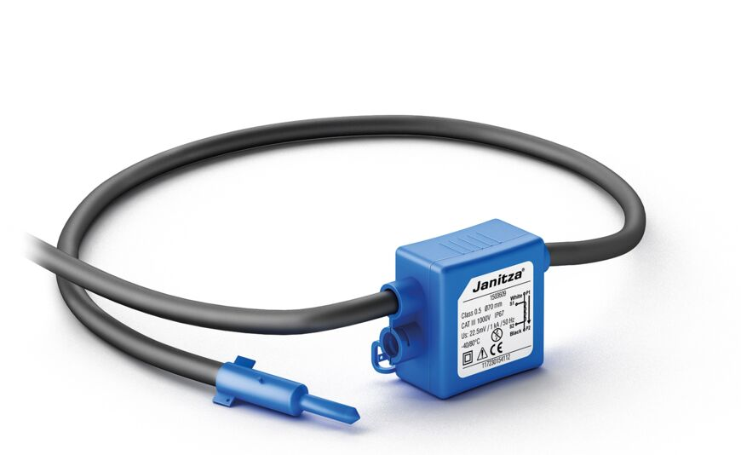

Fig 5: Image Of Rogowski Coil
Rogowski Coils contribute to the versatility of the Swiftvolt Kit by providing a non-intrusive means of measuring current.
Functionality:
Measures AC current without direct electrical contact, offering a flexible and adaptable solution for current measurement.
Enables the Swiftvolt Kit to assess power quality without disrupting the existing electrical circuit.
Key Features:
Non-Intrusive Design: The coils offer a non-intrusive approach to current measurement, making them suitable for various applications.
Flexible Placement: Their design allows for flexible placement around conductors, facilitating easy installation.
Applications:
Enhances the adaptability of the Swiftvolt Kit, allowing for current measurement in scenarios where traditional current transformers may be impractical.
In summary, each component in the Swiftvolt Kit plays a specialized role, collectively contributing to the project's objectives of efficient and reliable power quality measurement. The synergy of these components ensures that the Swiftvolt Kit stands as a comprehensive solution for a diverse range of applications in power quality analysis.

Hardware
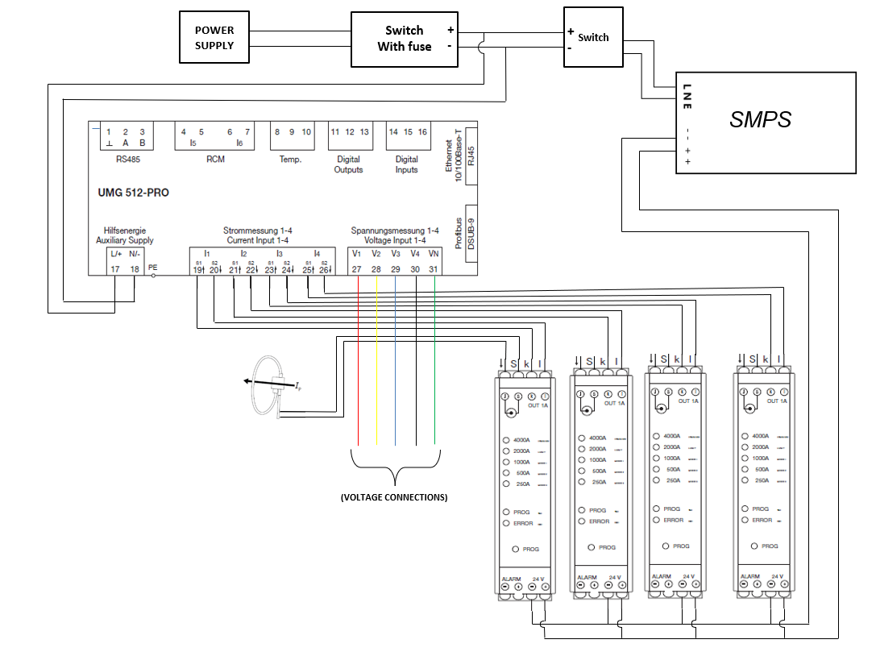
Fig 6:Circuit Diagram
In the provided schematic, the power supply is routed through a primary switch denoted as A. Upon activation, switch A facilitates power distribution to the meter. Additionally, the same switch, A, functions to convey power to switch B. Upon activation of switch B, power is subsequently supplied to the Switched-Mode Power Supply (SMPS). The SMPS, in turn, generates a 24-volt, 5-ampere power output directed towards the transducer.
Each transducer is connected to a Rogowski coil via two wires, while an additional pair of wires from each transducer is directed towards the meter for the purpose of current measurement. This configuration allows for a systematic and controlled power distribution, ensuring the requisite energy supply to both the meter and the transducers.
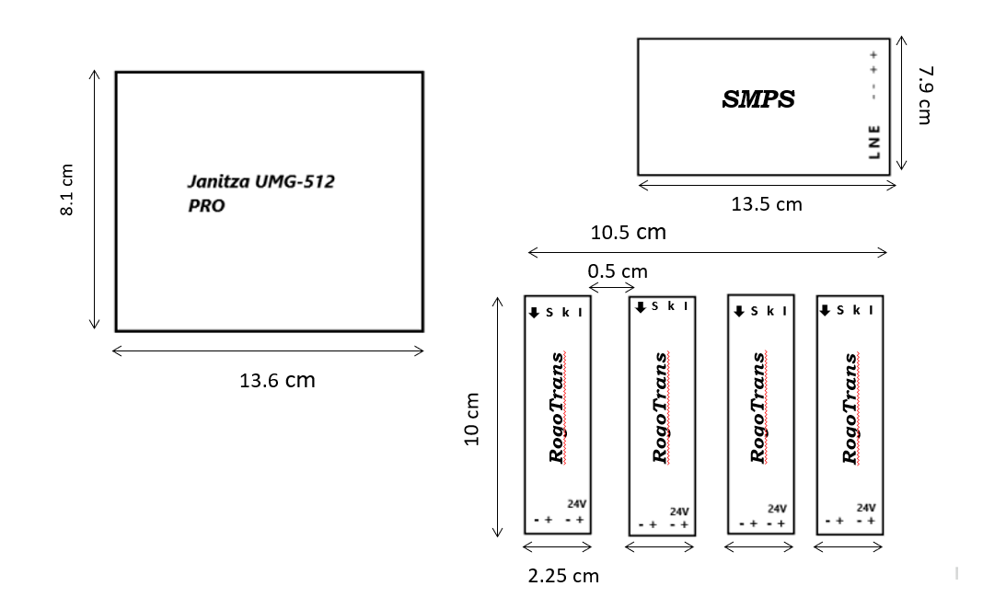
Fig 7: Inner Placements & their Dimensions

Costing

Following table gives the costing of the project.
Sr. No. | Specification/Description of component | Quantity | Unit Cost (`) | Total (`)
 | Current Connectors Caps | 5 | 38.8 | 194
 | 2 pin current connectors | 5 | 42.4 | 212
 | Elecom Power Switch | 1 | 120 | 120
 | Rocker Switch | 1 | 40 | 40
 | Ethernet Cord | 1 | 212 | 212
 | RS485 Connector | 1 | 20 | 20
 | Voltage Connectors | 5 | 20 | 100
 | Profibus Extender | 1 | 70 | 70
 | Dim Rail | 1 | 60 | 60
Total Cost (`) |  |  |  | 1,028

Member work sheet

Following table gives the details of the work allotted and completed by each member.

Sr. No. | Member Name | Work allotted | Work completed
1. | Omkar N. Koli | Documentation & Research work
2. | Sai G. Patade | Designing & Placements
3. | Aditya S. Salunke | Connections Work & Research
4. | Yash C. Sonje | Designing & Placements,Documentation
5. | Mayur M. Vaidya | Connections Work & Research

Datasheets

- G. -E. Subtirelu, M. Dobriceanu and M. Linca, "Power quality analyzer," 2017 10th International Symposium on Advanced Topics in Electrical Engineering (ATEE), Bucharest, Romania, 2017, pp. 909-914, doi: 10.1109/ATEE.2017.7905043.
- F. R. Mas Noor, F. Ronilaya and M. N. Hidayat, "Harmonics Fault Study And Analysis Procedures Using Portable Power Analyzer And Solutions Using Active Harmonics Filters," 2022 International Conference on Electrical and Information Technology (IEIT), Malang, Indonesia, 2022, pp. 1-6, doi: 10.1109/IEIT56384.2022.9967898.

